1) Coupon redeem system - not done 2) News page layout – not done as requested

Homepage -should there be a way to redeem or access the deal or something in the detail of the deal that people could do to redeem – seems like something is missing - Should there be instructions on how to redeem?

Akash- We are showing popular deals added by admin not by advertiser.

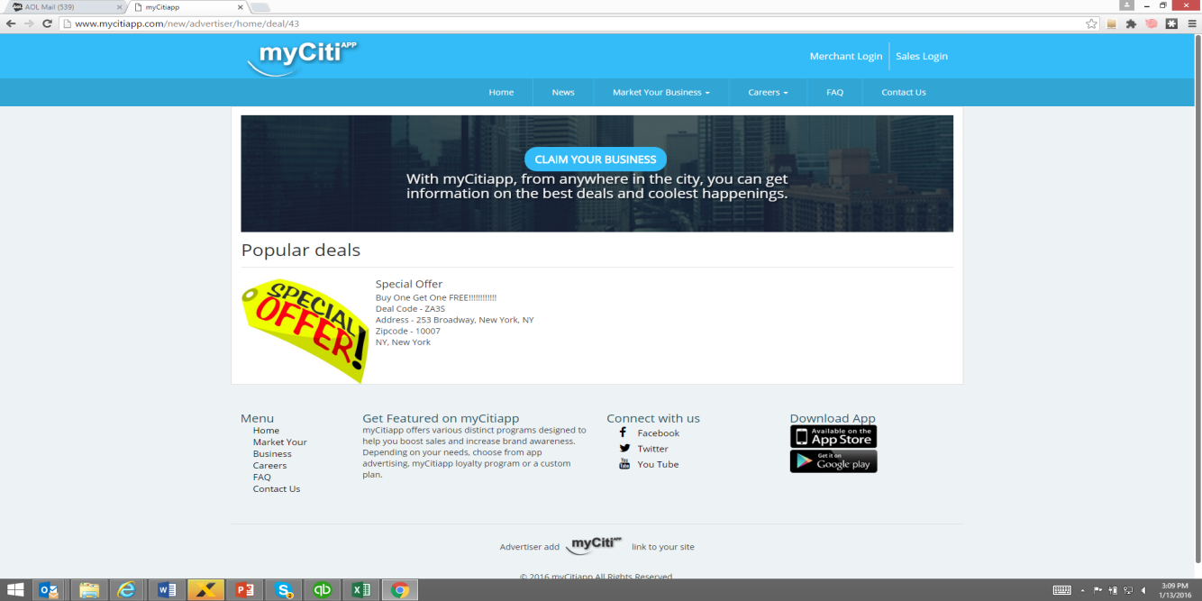

Featured advertiser

Shouldn’t the individual detail include all fields that are on app? How do people view and get deals that this advertiser offers? akash- as discussed with sir it is out of scope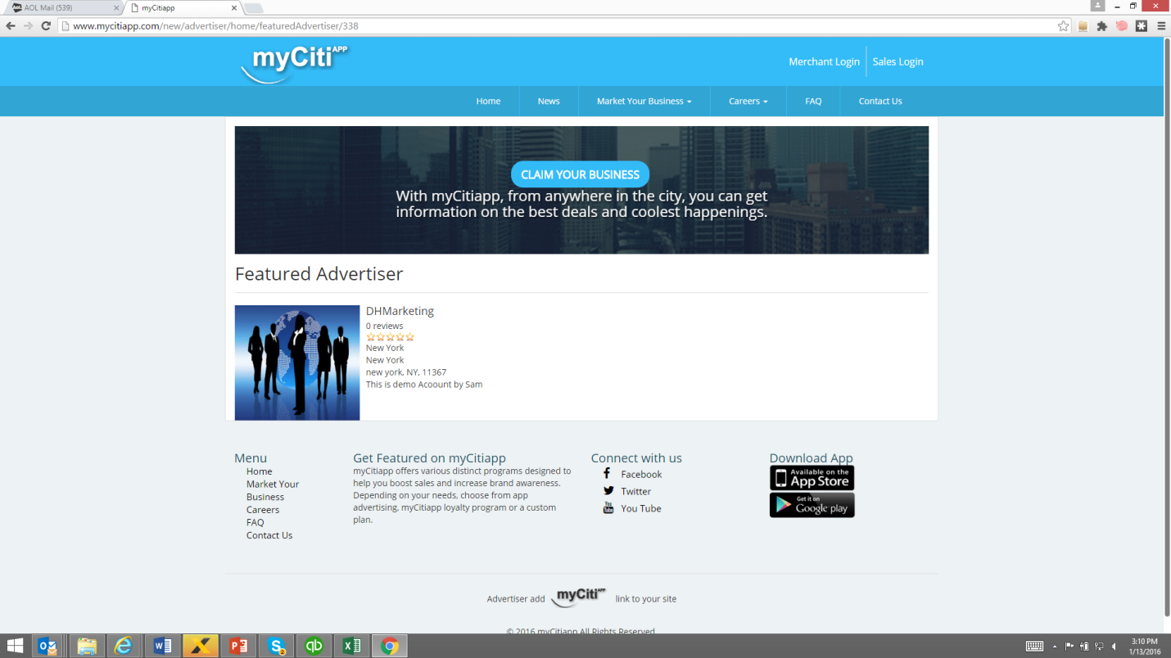

News page – take link of first article from belinda

Set this up so client can put a feature image to left next to the press release.

Have the title in blue as you have it. Then 1-3 lines and a link to pdf of press release or a link to a page showing full article.

|  |  |
| --- | --- |
|  | myCitiapp on MTA On The Go! Touch Screen Travel Station  New York, NY September 19, 2011 myCitiapp  is one of three apps featured on The On the Go! Travel Station -- a new interactive touch-screen travel kiosk launched today at the Bowling Green station as part of a pilot project covering a total of five subway stations and commuter rail hubs.read more…  myCitiapp is MTA App of the Week  This week's App of the Week, [myCitiapp](http://www.mycitiapp.com/), offers New Yorkers a free way to find nearby businesses and attractions and get to them using the MTA's trains and buses. [Read more.](http://www.mta.info/news/stories/?story=281)  A New iPhone App for Discovering the Best City Promotions and Attractions myCitiapp is Now Available Free from the App Store  New York, NY April 21, 2011, With the vacation season rapidly approaching, myCitiapp.com is pleased to announce the availability of its new, free App designed specifically for users of the Apple iPhone.  With special features and functions that are optimized for the iPhone's rich interface, the new [city App](http://itunes.apple.com/us/app/mycitiapp/id425132905?mt=8) takes users on a virtual tour of their City and enables "at a glance" browsing of the city's tourist attractions and sightseeing, entertainment, restaurants, local promotions, Broadway shows, shopping and much more. Read more |
|  |  |

Market your business

I just mean for bullet point to be blue not the text too in bulleted listing. Please update -Done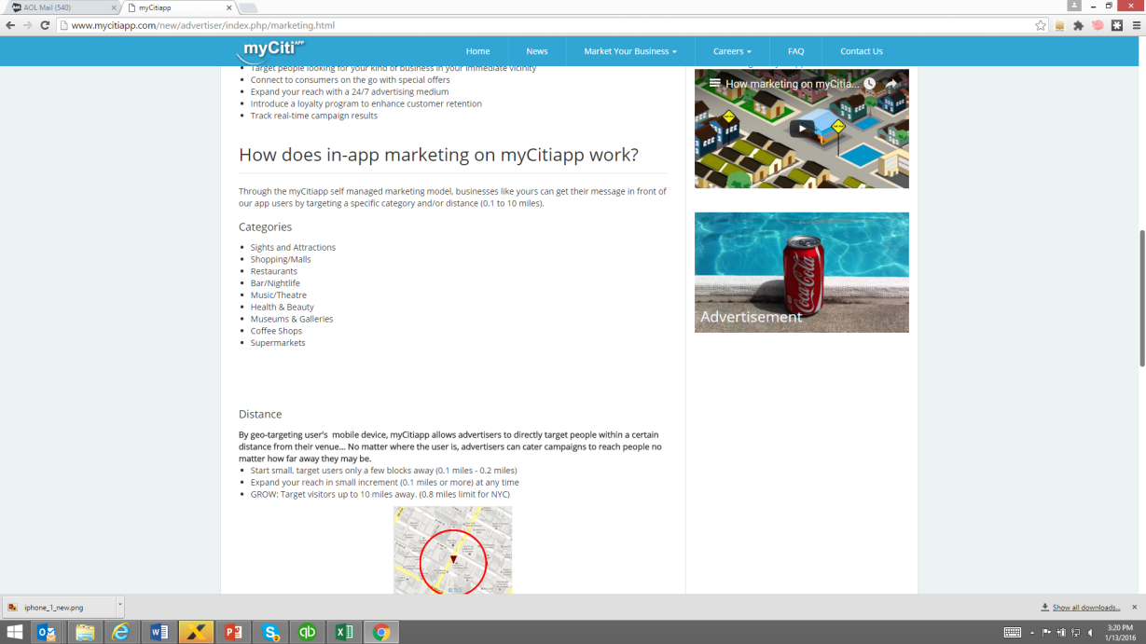

Loyalty program page

Can you take the sidebar out of the scroll? Done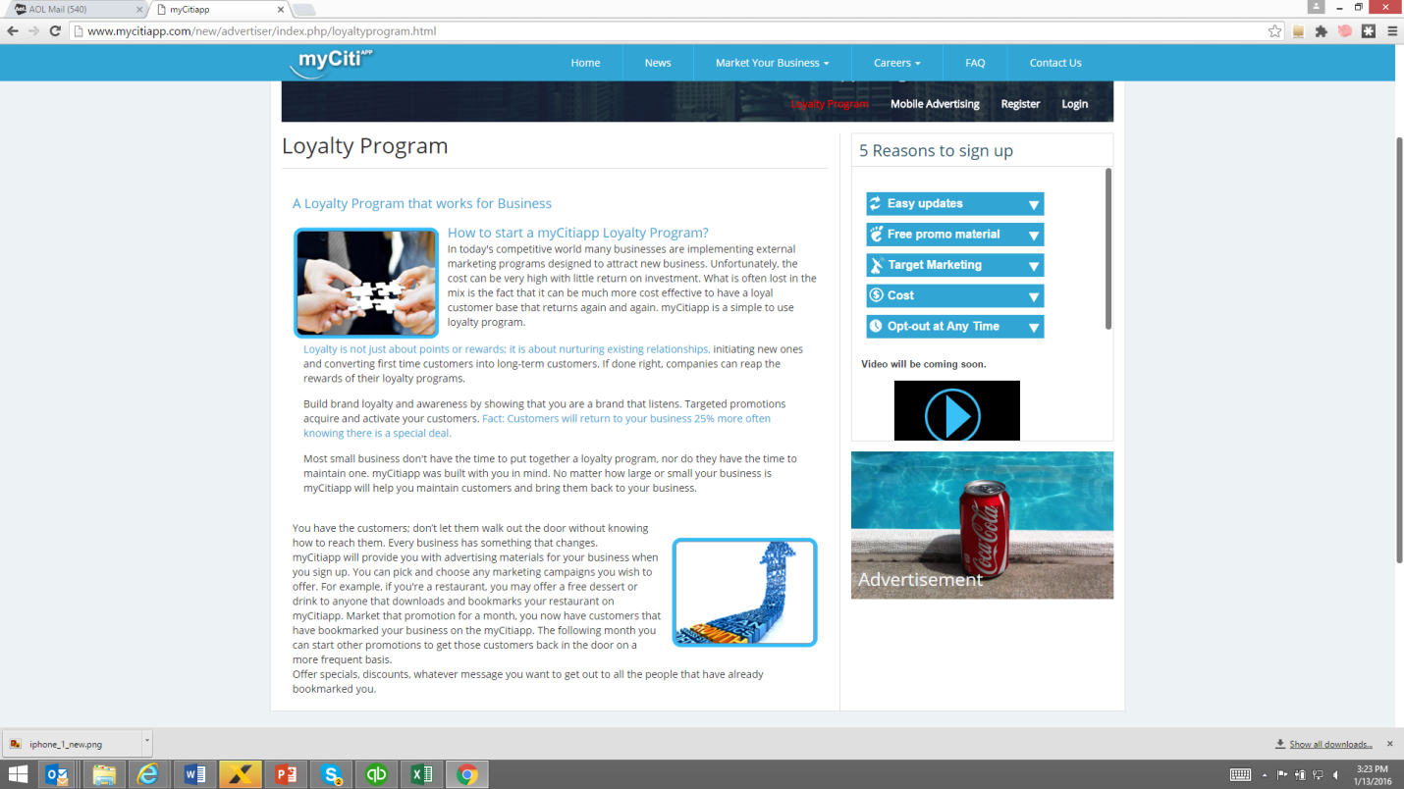

terms and conditions

looks like you are missing more than half the document. Can you also have names of page be in consistent font. Why do we have an ad on this page? Done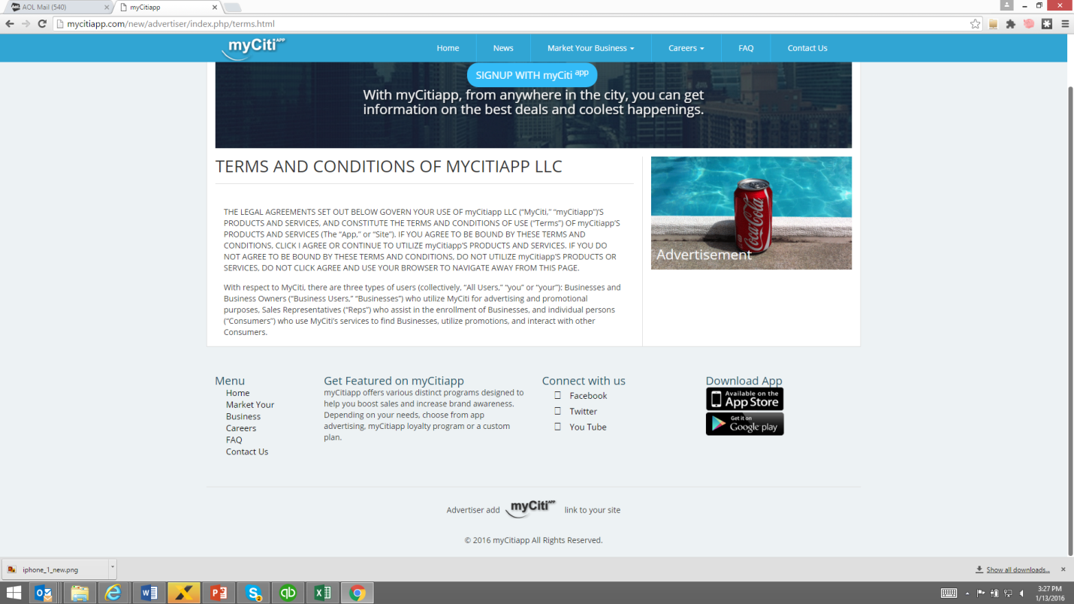

Careers

Font is all different sizes. Please fix and make this all consistent. Font-is same on this page

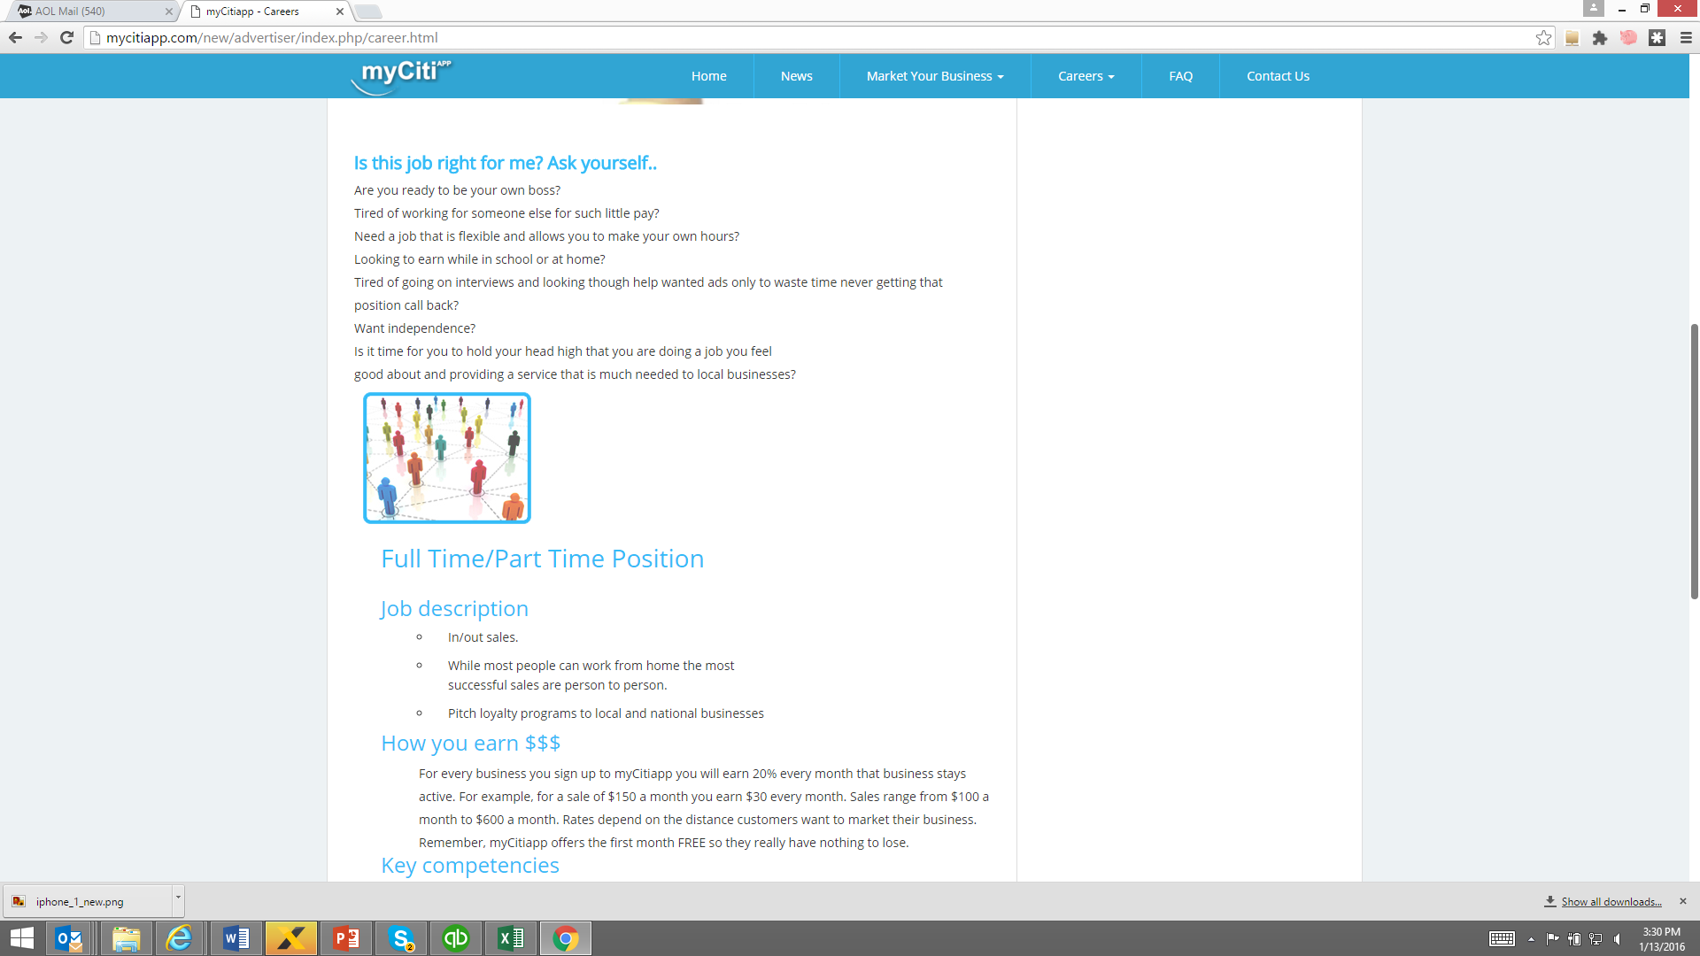

Claim a business

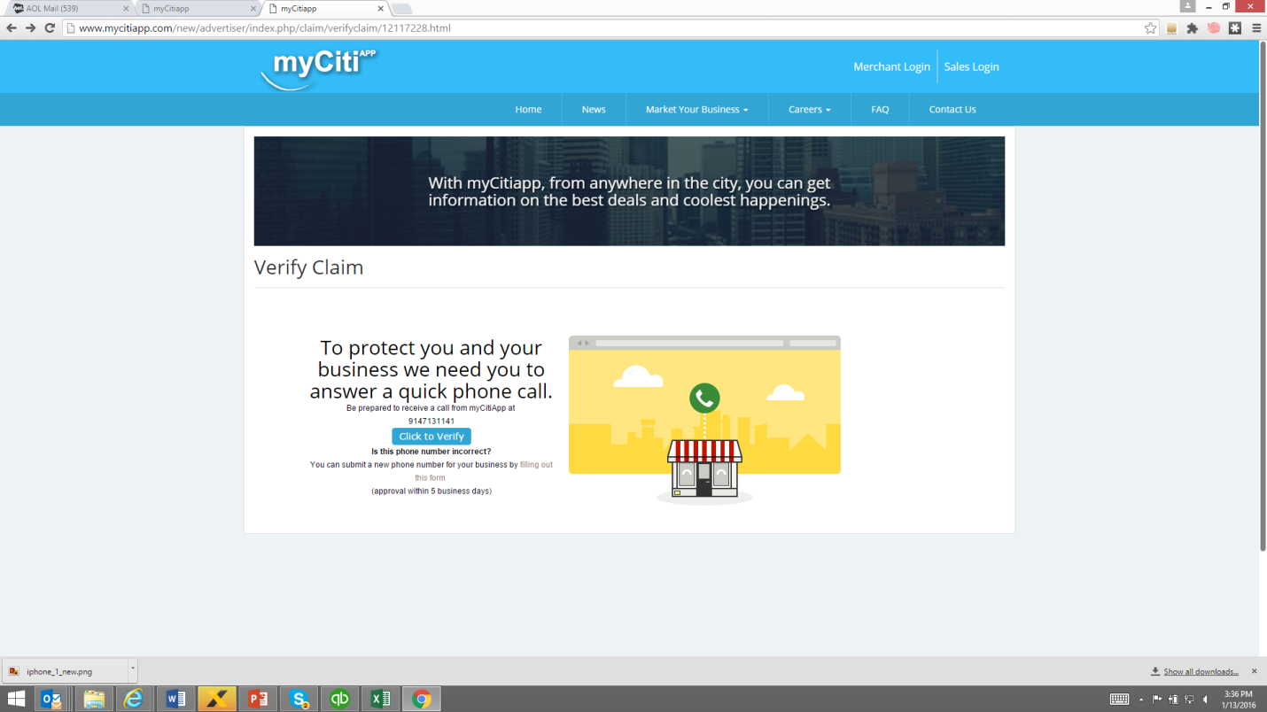

When I click on incorrect phone number and fill out a form. It takes me to this page on existing site. See below. This is not finished. This point is done

Also I wanted to claim with business email and told we it was already on system. So I couldn’t claim with business email. Add comment as discussed with sachin sir

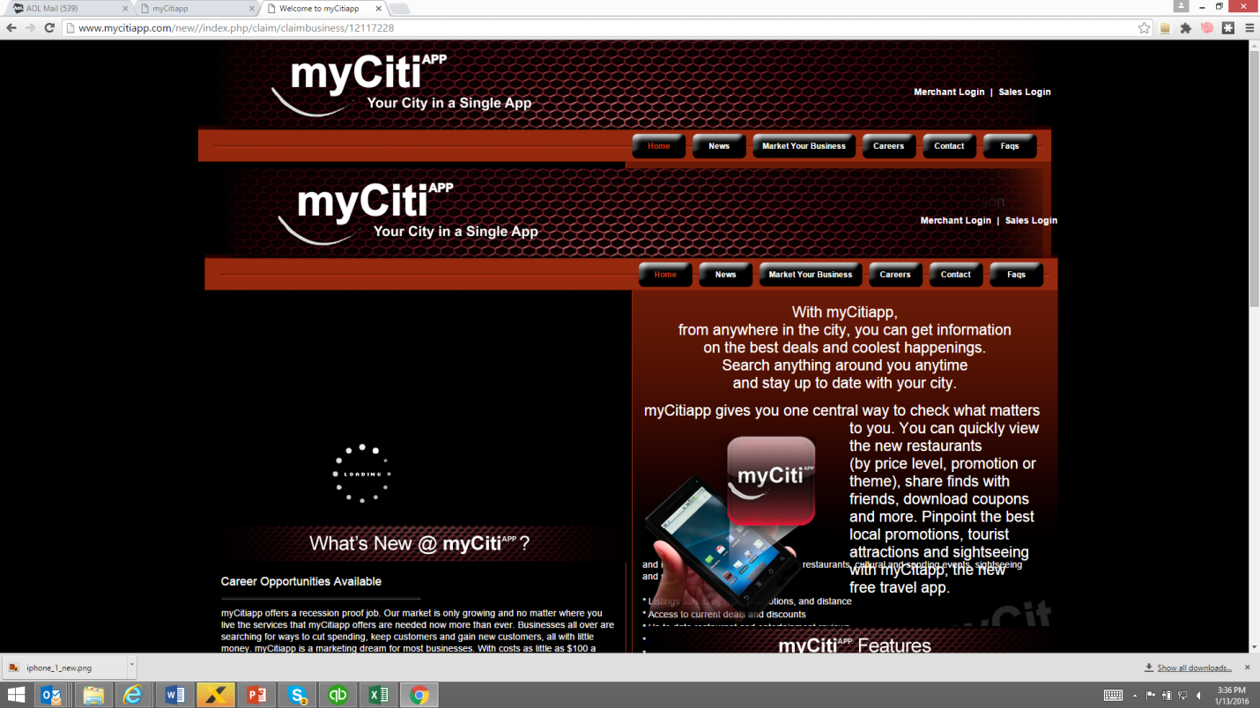

Add business

When I go to add a business, it seems to be advertiser registration. What if a business only wants to add their business to do? I think something is missing here. Sam you need to look at this. –

There is another panel for adding business by advertiser.

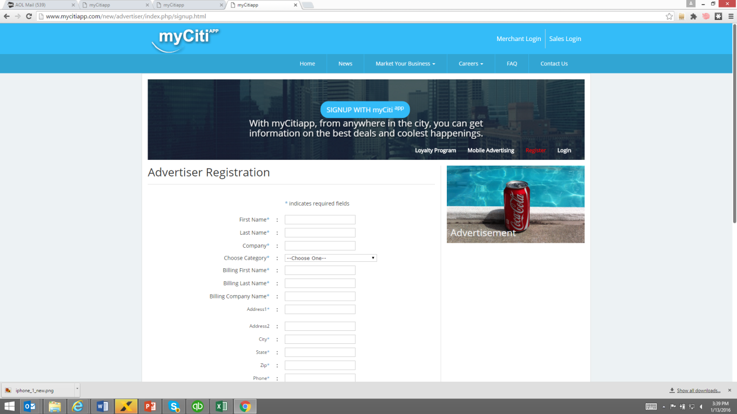

What if someone has more than one business and wants all communications linked to one email why second line of address is mandatory. Not all companies have two line addresses. Can you remove that? This is done

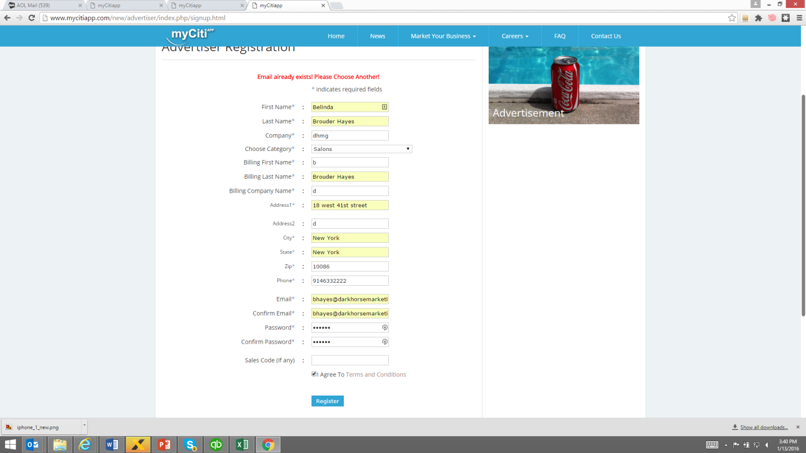

Again they are adding business not registering so something is wrong with logic here. Why is confirmation message in green instead of blue? 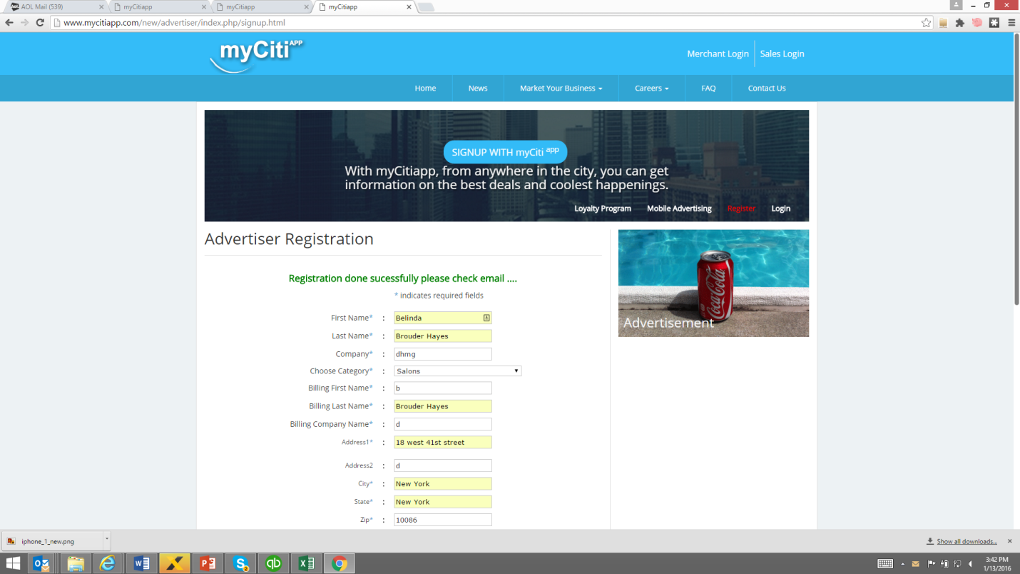

I couldn’t see what send was after adding so unsure of what happens after this point.

When submitted, this screen doesn’t seem to make sense either. Did anyone review this?

Emails are not coming from mycitiapp server. That’s why not checked below screenshots.

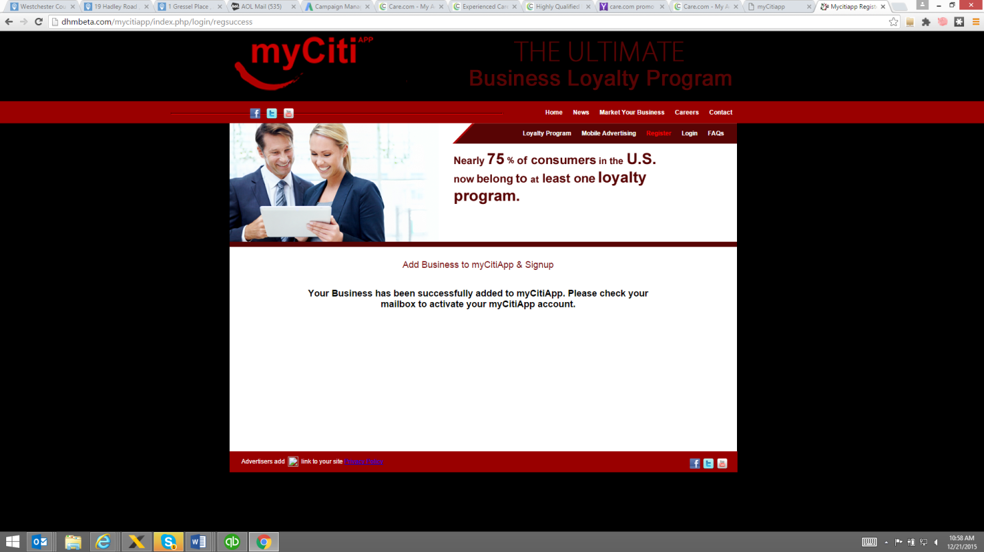

When I add claim a business. I do not expect to receive confirmation on advertiser sign up so this needs to be fixed. See what I got in email – again it is the old design.

